**Lab no 1**

**Introduction to Machine Learning and Setting the Environment**

**Objective**

* To understand the basic concepts of Machine Learning.
* To set up the Python environment using Anaconda.
* To install and use fundamental machine learning libraries like NumPy, Pandas, Matplotlib, and Scikit-learn.

**Introduction**

Machine Learning (ML) is a core area of Artificial Intelligence where systems learn from data and improve performance without being explicitly programmed. It is widely applied in fields like image recognition, autonomous vehicles, predictive analytics, and natural language processing.

There are three main types of machine learning:

* **Supervised Learning** – learns from labeled data (e.g., classification, regression).
* **Unsupervised Learning** – finds patterns in unlabeled data (e.g., clustering).
* **Reinforcement Learning** – learns from interactions with an environment.

Before implementing machine learning models, we need to set up the development environment. Python is the most commonly used language for ML due to its simple syntax and vast library support. Anaconda simplifies the setup process by providing all required tools and libraries in one platform.

**Tools and Libraries**

| **Tool** | **Purpose** |
| --- | --- |
| **Anaconda Prompt** | Command-line interface for managing Python environments |
| **Jupyter Notebook** | Interactive environment for code and documentation |
| **NumPy** | Numerical computing library |
| **Pandas** | Data analysis and manipulation |
| **Matplotlib** | Data visualization |
| **Scikit-learn** | ML algorithms and data preprocessing |

**Procedure**

**Step 1: Open Anaconda Prompt**

* Click **Start** → Search **Anaconda Prompt** → Open it.

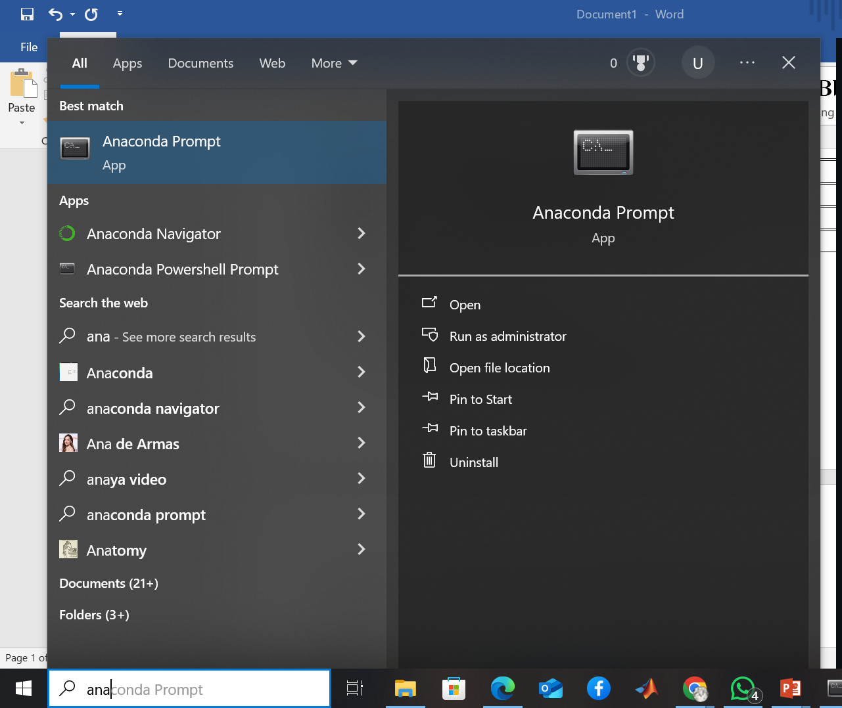

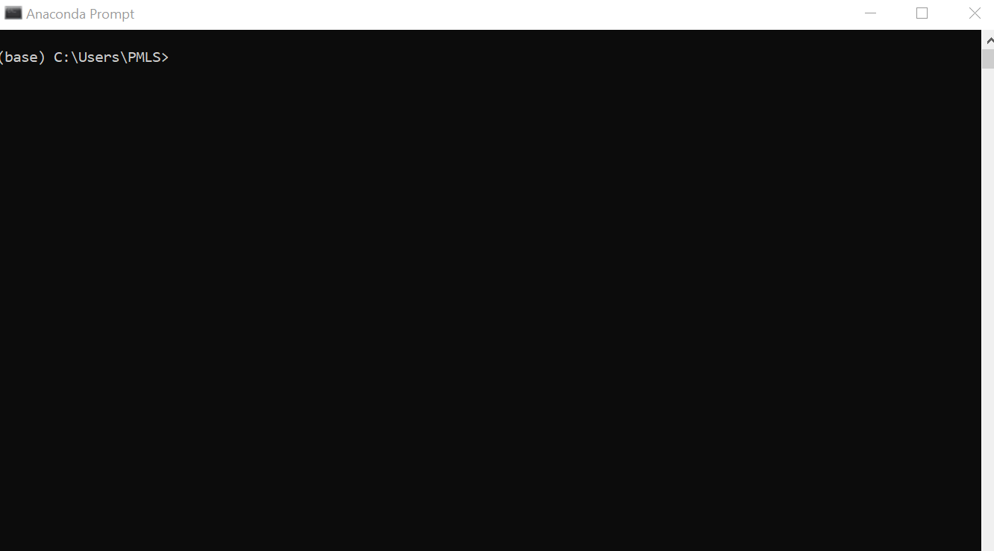

**Step 2: Create a New Environment**

conda create --name umar python=3.9

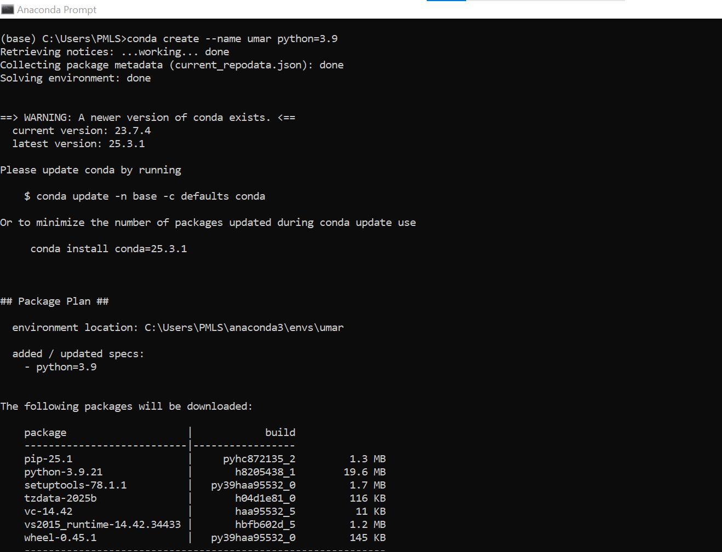

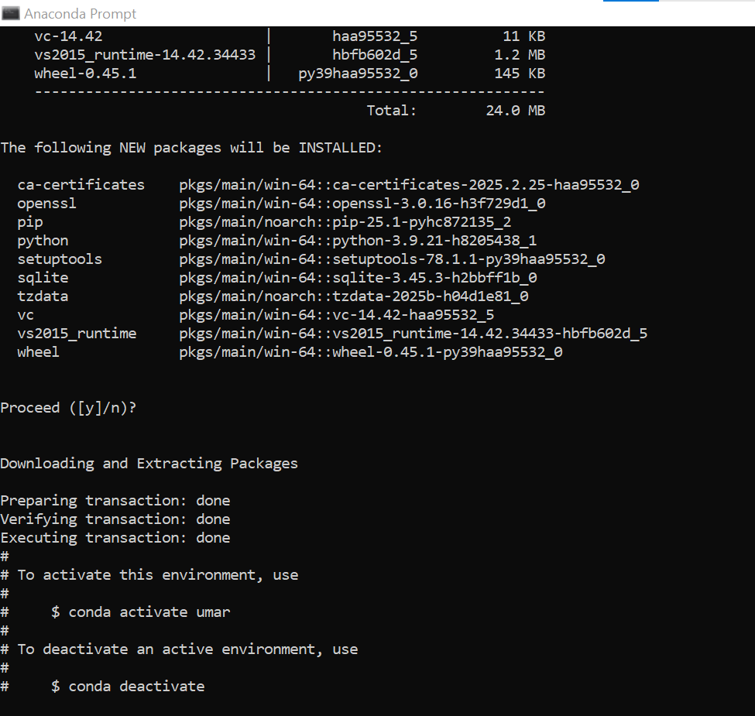

**Step 3: Activate the Environment**

Write  
conda activate umar  
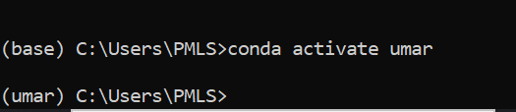

**Step 4: Install Required Libraries**

Write  
conda install numpy pandas matplotlib scikit-learn jupyter

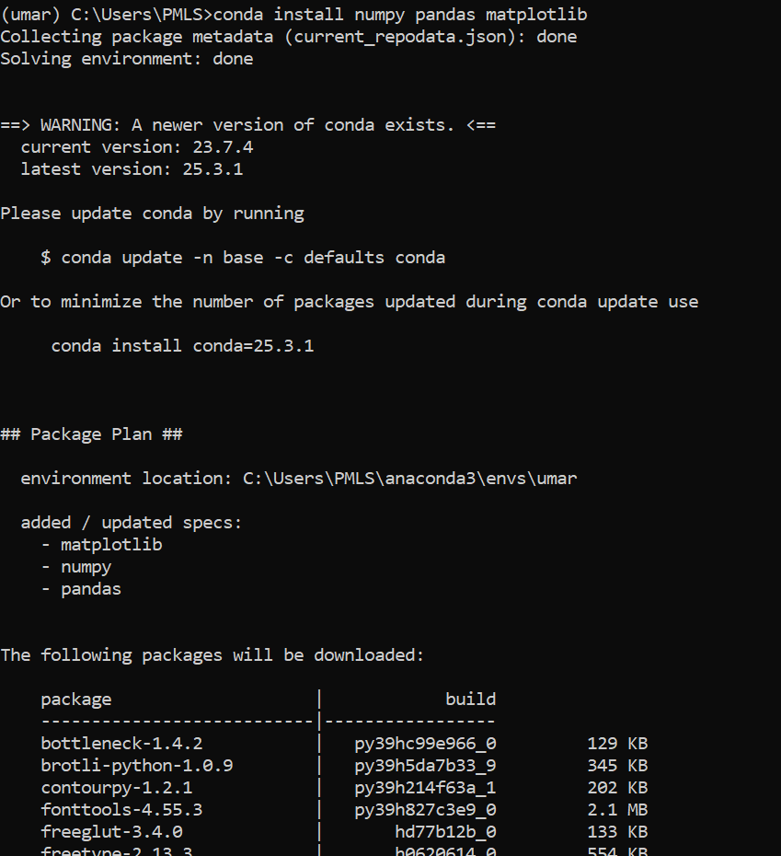

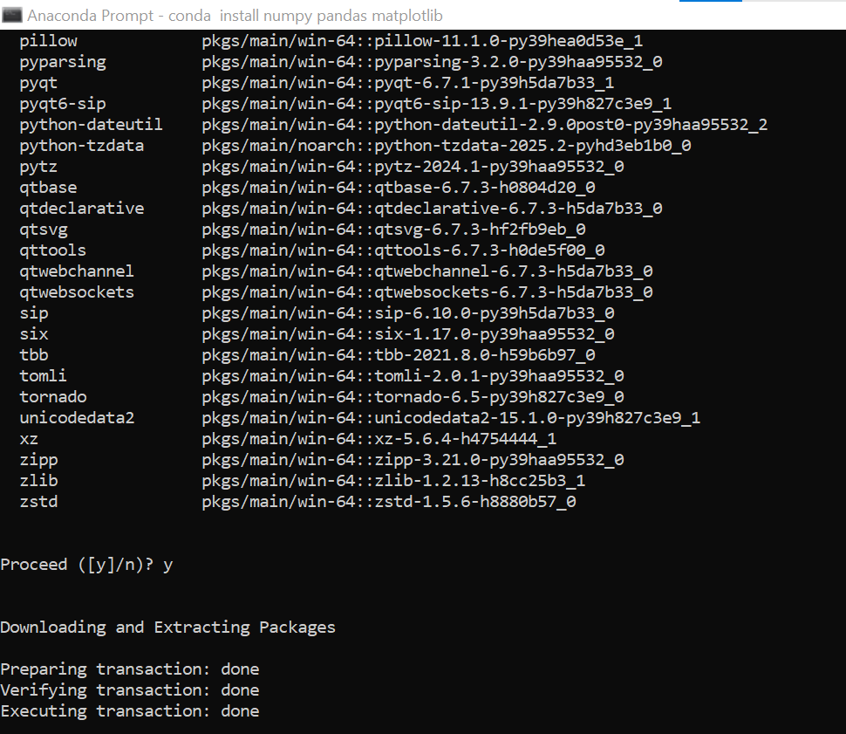

**Step 5: Launch Jupyter Notebook**

jupyter notebook

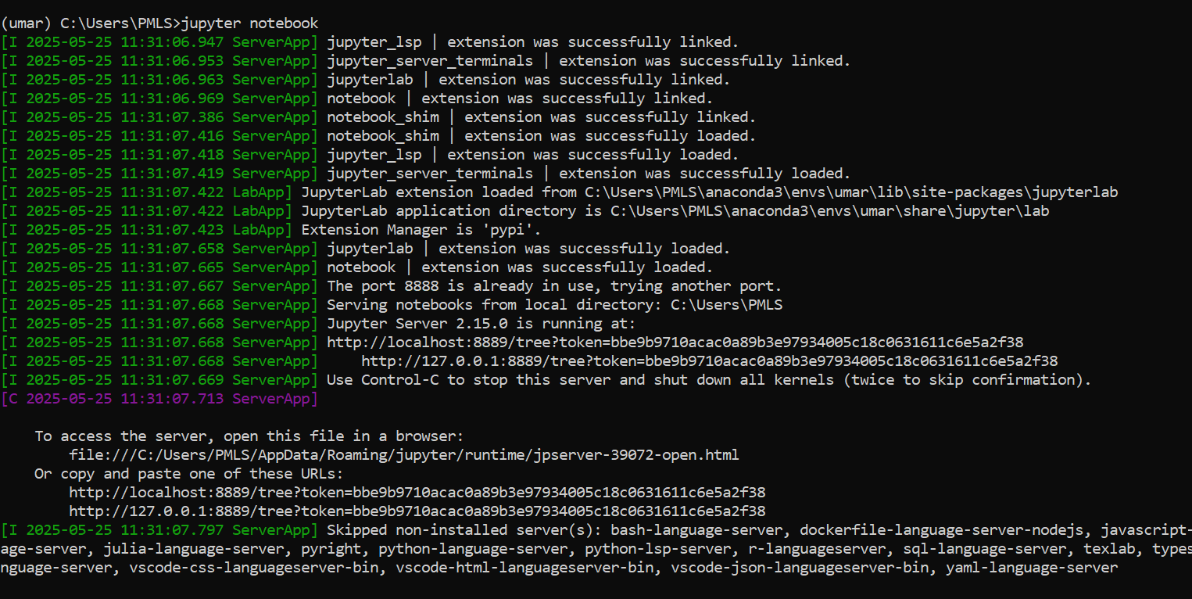

* This will open Jupyter in your default browser.
* Click **New → Python 3** to open a new notebook.

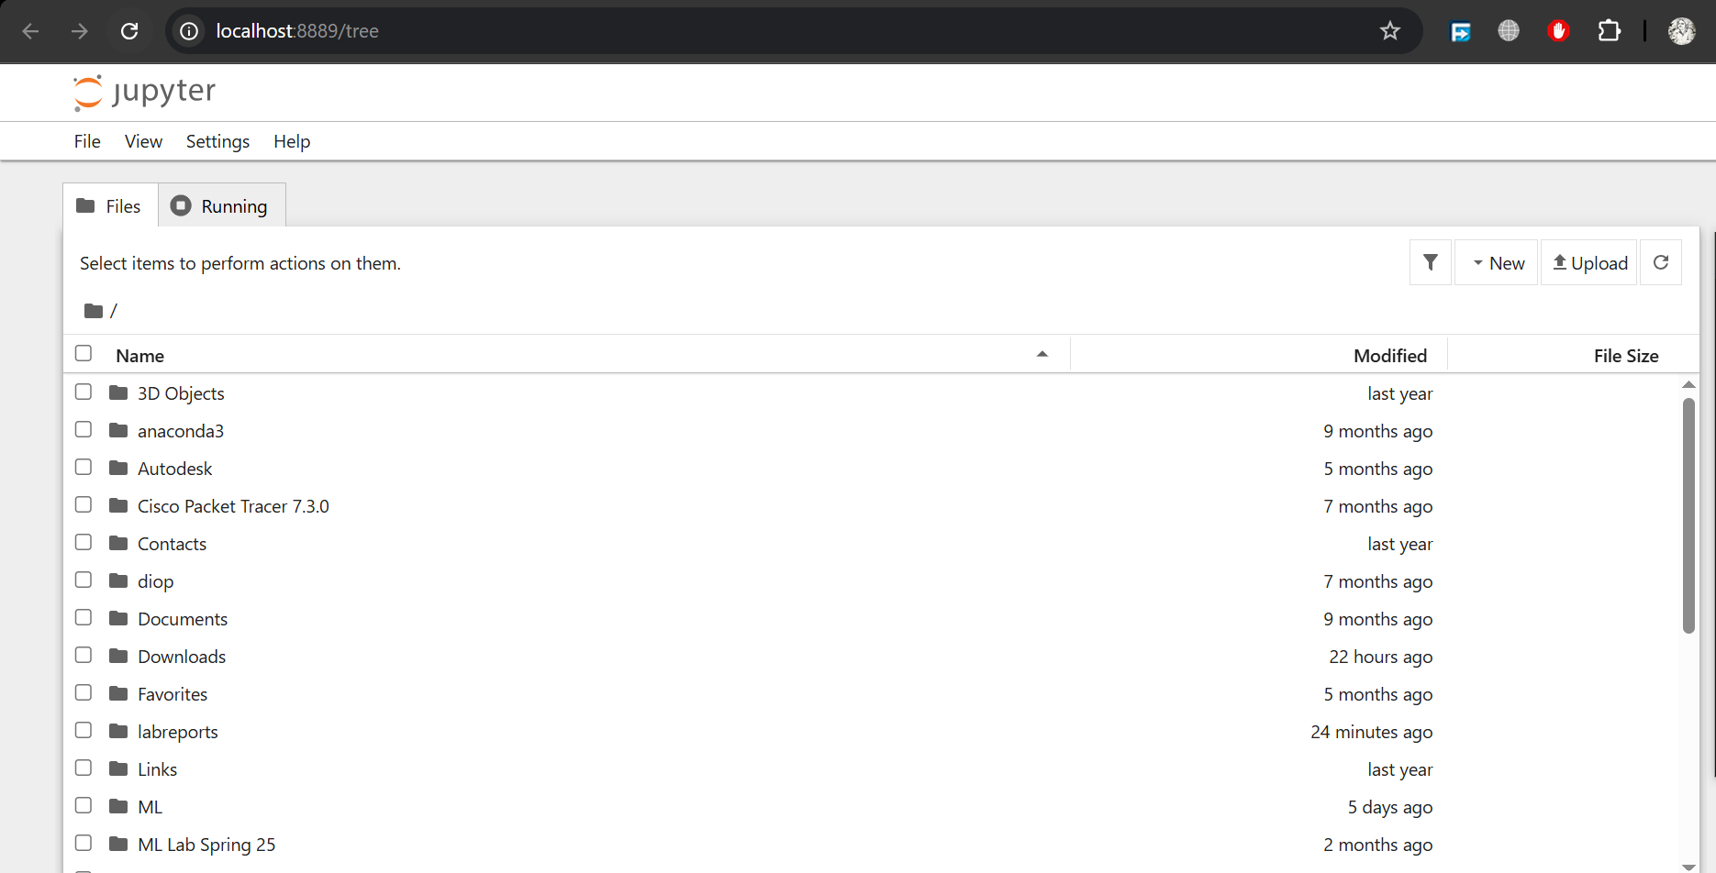

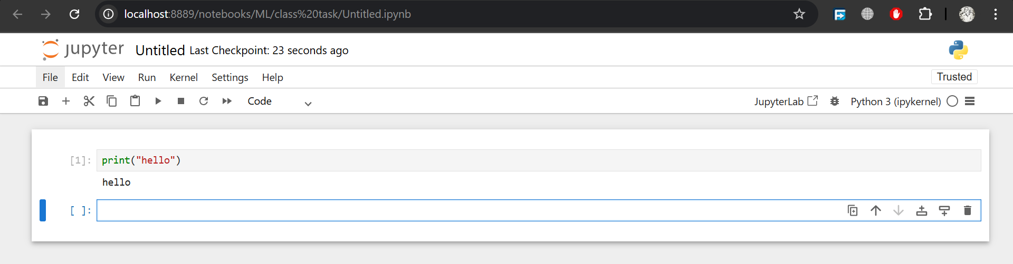

**Results**

* Successfully created a conda environment and installed the necessary libraries.
* Launched and worked in Jupyter Notebook via Anaconda Prompt.

**Conclusion**

This lab successfully introduced Machine Learning and demonstrated how to set up a working ML environment using Anaconda Prompt. By using conda environments and Jupyter notebooks, we created a reliable and organized workflow for ML projects.